 |  | SUMMERFIELD ELEMENTARY
December 2017 |  | 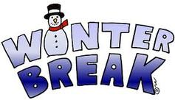  Important Information:  Winter Break 12/22/2017-1/2/2018  The School will be closed.
Sun | Mon |  | Tue | Wed | Thu | Fri | Sat
 |  |  |  |  |  | 1  Fabulously Fun Friday for $1 presents  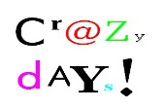  Last day for  Santa Shop  End of 1st Marking period | 2
3 | 4  After School Art  2nd grade food Drive |  | 5  Ornament Class 3:15-4:15  2nd grade food Drive | 6  NO Spanish  2nd grade food Drive | 7  5th-12th grade band concert 7 pm  2nd grade food Drive | 8  Report Cards will be distributed  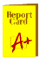  2nd grade food Drive  Last day to buy Bear Raffle Tickets | 9
10 | 11  Last After School Art until January  2nd grade food Drive  Board Meeting 7:00 |  | 12  1-3 grade music concert 1:30 & 7  2nd grade food Drive  Dawg Den will be opened | 13  NO Spanish  2nd grade food Drive | 14  2nd grade food Drive | 15  Last day of the 2nd grade food Drive. All items will be picked up before 10:00 am | 16
17 | 18 |  | 19  PTO meeting 3:30  Winter Scrapbooking 3:15-4:30 | 20  NO Spanish | 21  ½ Day Dissmissal @ 11:55 for  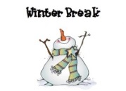 | 22 | 23
24 | 25 |  | 26 | 27 | 28 | 29 | 30
31 |  |  |  | See you on Wednesday, January 3rd

