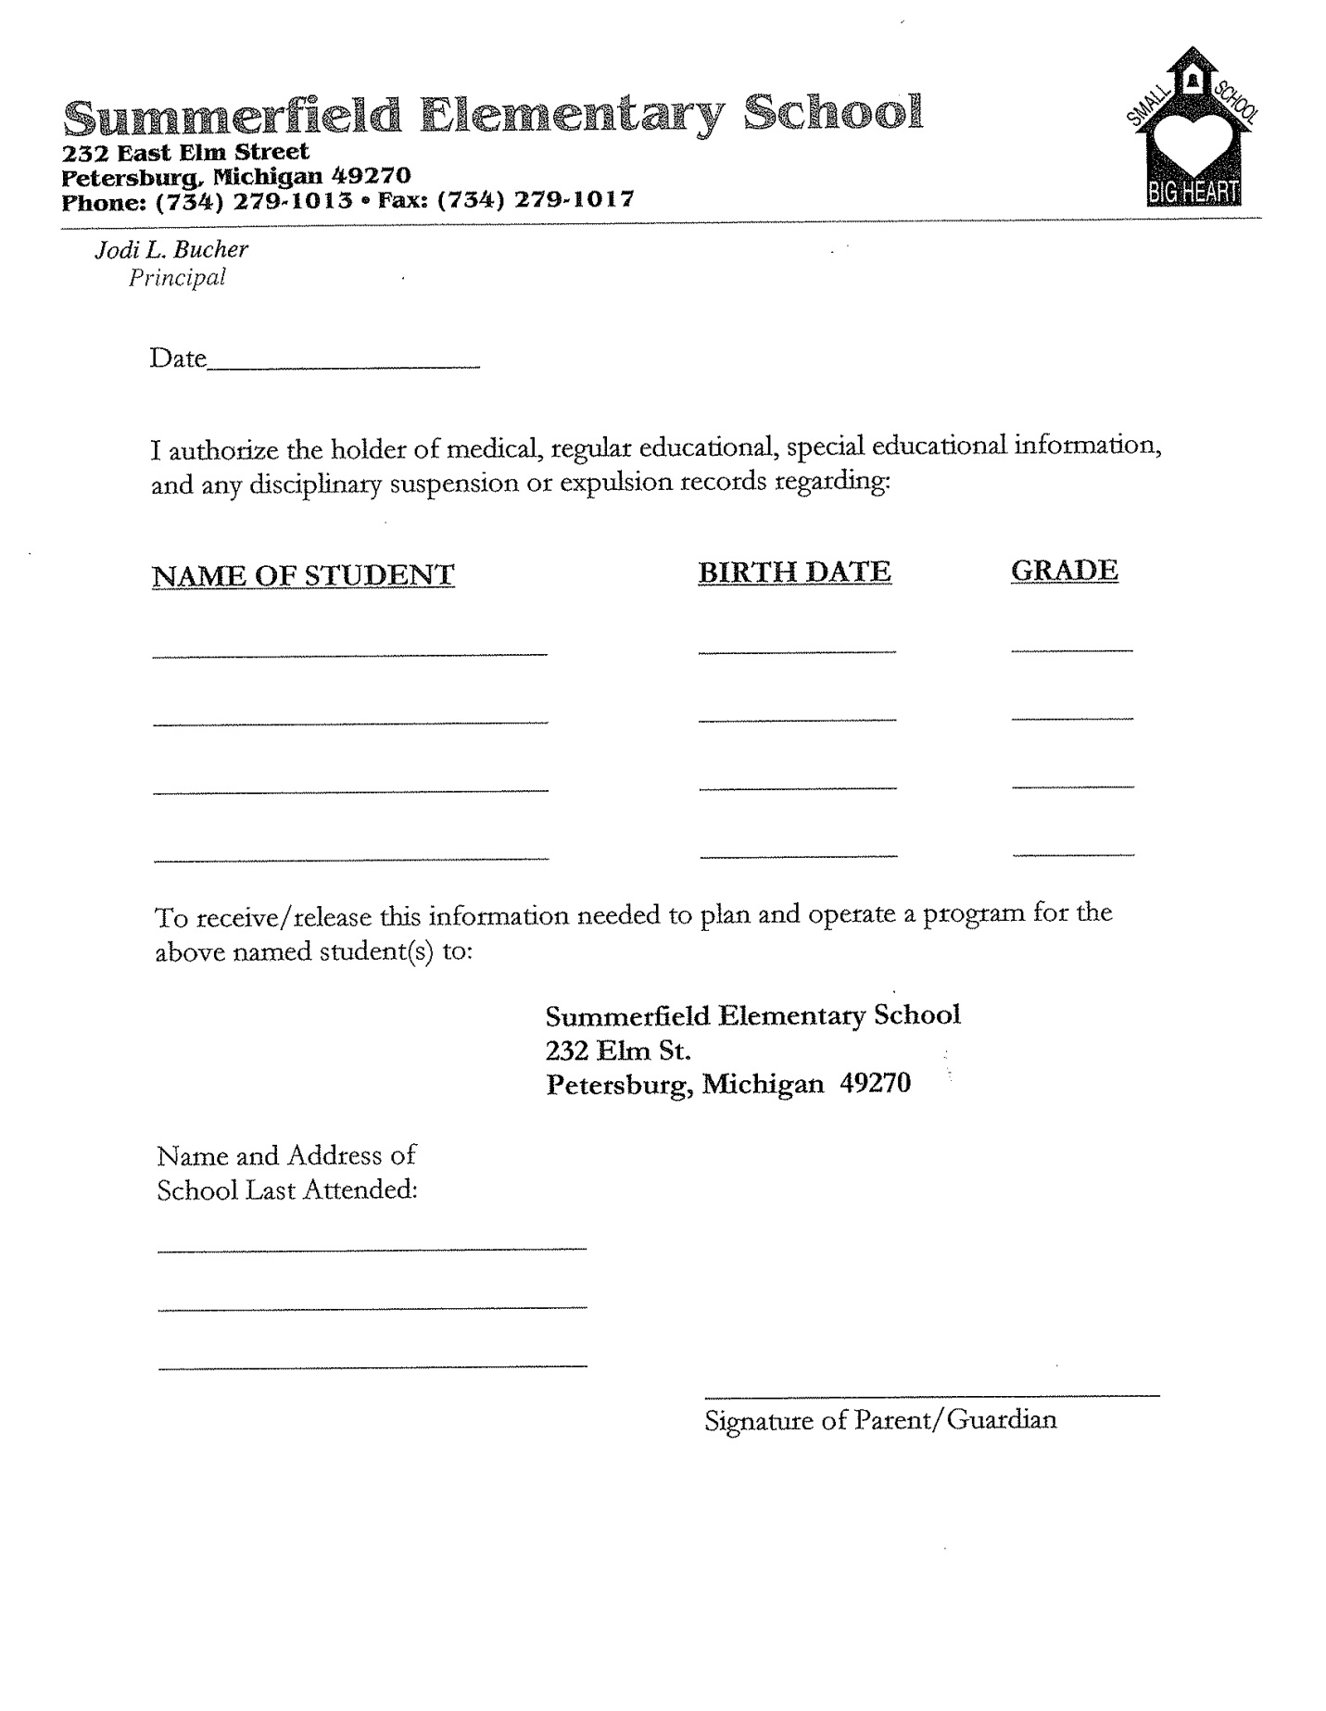

Phone:____________________

Fax:______________________